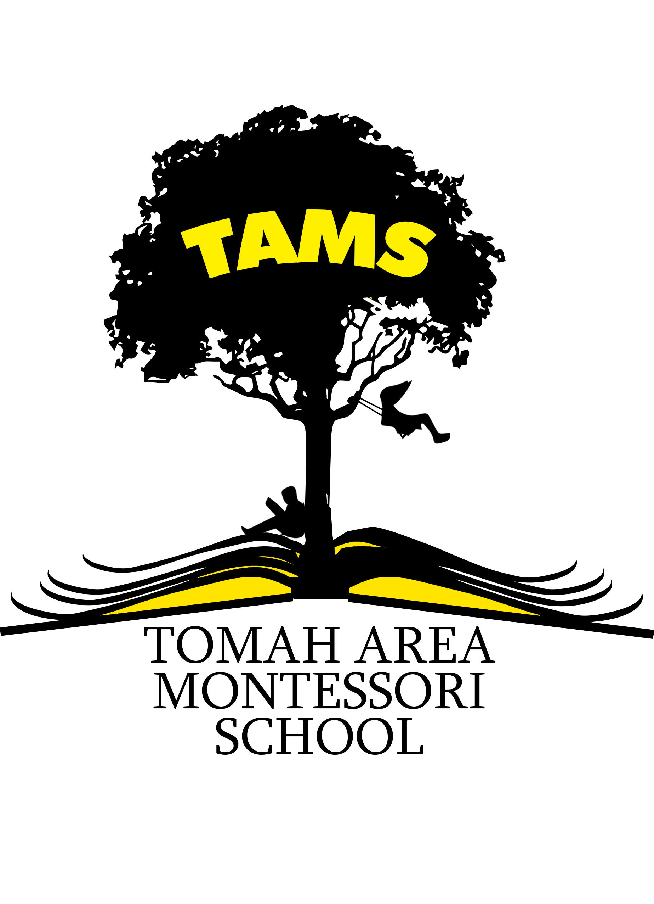Parent/Student Handbook
2020-2021

PArent Handbook

Introduction

Tomah Area Montessori School Mission

Recognizing that the first years of learning are vital to future success, TAMS will foster a lifelong love of learning by creating a classroom that is individualized and engaging for the child.

Family Involvement
Individualized Success
Respect of Others, Self and Environment
Engaging Classroom

GOALS:

- Develop a lifelong love of learning and executive function skills with engaging, hands-on materials and child-centered instruction
- Create a respectful and nurturing classroom and school community
- Increase family involvement in school
- Close the achievement gaps among students of varied socioeconomic statuses in math and literacy
- Retain Montessori-certified staff committed to professional development through a Professional Learning Community and collaborations with elementary and university educators

“Our aim is not to merely make the child understand, and still less to force him to memorize, but so to touch his imagination as to enthuse him to his inner most core.” (Maria Montessori, 1948)

Philosophy of Tomah Area Montessori School

Dr. Maria Montessori, Italy’s first female physician, opened her first “school” (Casa dei Bambini) in 1907. Based on her observations of children, she developed what has become known as the Montessori approach to education. Fundamental to all of Dr. Montessori’s ideas is a deep respect for a child’s ability to learn. She recognized that children pass through certain phases she called “sensitive periods” between birth and age six in which they learn more easily than at any other time in their lives. This potential to learn is dependent on a loving environment that encourages the active pursuit of knowledge.

Dr. Montessori’s developmentally appropriate approach to learning is designed to fit each child instead of making each child fit into a preset program. She believed that learning should take place in multi-aged classrooms where children who are at various stages of development can learn from and with each other. This learning should take place in a non-competitive atmosphere in order for each child to develop at his/her own speed. Children are grouped from ages 3-6 in the Children’s House, from 6-9 years old in the E1 program, and 9-12 years old in the E2 program.

Dr. Montessori observed that the best way young children learn is through active, hands-on experiences. She developed the idea of the prepared environment, where the classroom contains a wide variety of materials that encourage learning in many areas. The purpose of the materials is not just to impart knowledge to children, but also to help them acquire something infinitely more precious-the unfolding of his or her human potential and value to mankind.

To aid in this process, classrooms are set up according to these concepts:
- Free flow of socialization and movement within the classroom
- Freedom of choice in selection of materials
- Respect and guidance on self-initiated tasks
- Large blocks of work time to allow for full access and development of projects
- Individualized expectations and goals
- Provision for real life experience and presentations of expanded subject matter

Table of Contents

SCHOOL GOVERNANCE, QUALIFICATIONS, PROGRAM
School Governance Board………………………………………………..……………...……….…………4
Enrollment……………………………………….……………………………………………………….…4
School Principal………………………………….…………………………………………………………4
Staff Qualifications………………………………………………………………………………......…......4
Curriculum…………………………………………………………………………………………...….….5
Programming………………………………………………………………………………………………..7

ATTENDANCE
Hours……………………………………………………………………………………………..…………7
Attendance, Tardies, Late Arrivals, Truancy…………………………………………………….…………7
Illness Guidelines……………………………………………………………………………………..…….8
School Closings…………………………………………………………………………………….....…….8
4K Calendar……..….……………………………………………………………………………….......…..9
School Calendar……..…………………………………………………………………………………..…10

IN THE CLASSROOM
Testing……………………………………………………………………………………………...…....…11
Virtues…………..………………………………………………………………………………...….…….11

PARENTS
Communication……………………………………………………………………………………...….….11
Confidentiality/Privacy…………………………………………………………………………...…….….11
Visiting, Tours, Volunteers………………………………………………………………….........…….….11
Parent Teacher Organization (PTO) ……………………………………………………………......……..12
Parent Education Meetings……………………………………………………......……………...…….….12
Volunteer Service………………………………………………………………........…………...….…….12
Parent Concerns…………………………………………………………………...........………...…….….12
Parent/Teacher Conferences ………………………………………………………………………..….….13
Student Placement…………………………………………………………………….......……....……….13

STUDENTS
Bullying………………………………………………………………………........................…...……….13
Proper Dress…………………………………………………………………………....................……….13
Sharing Student Information…………………………………………………………………...…....…….13
Student Code of Conduct………………………………………………………………………....……….13

NUTRITION, HEALTH, and RELATED ISSUES
Food Services…………………………………………………………...............………………...…….….13
Snacks……………………………………………………………………..........................……...…….….14
Immunization Records…………………………………………………………….……………...…….….14
Eye Examinations………………………………………………………………………........…...…….….15
Medications………………………………………………………………………….....................……….15

SAFETY
Safety and Security………………………………………………………………………….........….…….15
Transportation…………………………………………………………………………...……...............….15
Non-Discrimination………………………………………….………………………………........…….….16

A complete copy of TAMS policy is available at www.tomah.education.

SCHOOL GOVERNANCE, QUALIFICATIONS, APPROACH

Tomah Area Montessori School is a charter school, which is a public school that operates on a five-year contract with the school district in order to provide a different learning environment. This contract allows TAMS to waive district policies and operate with greater flexibility and autonomy in order to utilize Montessori education. The unique character of charter schools means that parents should not expect that all of the programs and policies at the other district elementary schools will be offered at TAMS. Charter schools are expected to maintain high student achievement.

TAMS Governance Board
A Governance Board made up of parents, educators, and community leaders is directly responsible for leading the school and sustaining the vision and mission of TAMS. The Governance Board meetings are open to the public, and meeting minutes can be found on the Tomah Area School District Website. Current TAMS Governance Board Members are: Pam Melby (President), Adam Bubnich (Vice President), EmmyLou Houston (Secretary), Rachel Linehan (Treasurer), Cindy Best, Becky Bauman and Spencer Stephens.

Interested parents and community members may serve on one of the committees that report to the Governance Board.

Committees:
PTO/Engagement: To assure the school as a co-creation through strong family and community partnerships

Curriculum: To support and sustain the Montessori pedagogy as a means to promote achievement

Communications: To serve as ambassadors for the TAMS story

Finance: To ensure the fiscal viability and sustainability of TAMS

Enrollment
Current students do not need to enroll for the following year. Siblings of current students will need to enroll during the open enrollment window which begins in February, and will have first priority. Other students interested in attending TAMS will be invited to enroll during the open enrollment window. If the number of students who apply exceeds the capacity of open seats available, then a lottery shall be conducted.

School Principal
JoLynn Schmidt
608-374-7094
jolynnschmidt@tomah.education

Staff Qualifications
Each Montessori classroom is directed by a Montessori trained teacher, trained at an AMS (American Montessori Society) or AMI (Association Montessori International) accredited training center. All teachers hold Wisconsin state teaching licenses and may hold Master’s degrees. Staff and students may have access to a special education teacher, a speech pathologist, guidance, music, physical education, an art teacher, and a custodian. There may be instances where an untrained Montessori teacher will have to direct a classroom. However, every effort will be made to hire trained Montessori staff members.

Montessori Approach
The Core of Maria Montessori’s theory is based on using hands and senses (touching, smelling, hearing, seeing and tasting), which leads to intellectual development, as this is the way children learn about the world and later use the gained knowledge to develop abstract thinking.

Curriculum:
Practical Life
This area is a logical first step in the classroom, as it resembles the kitchen of the home. Preparatory work includes activities such as dishwashing, scrubbing tables, pouring, dusting, buttoning, sewing, and cooking. These activities enable the child to develop his own inner discipline through the use of his hands and prepare the child’s hand muscles for writing. The child learns to care for himself and his environment. Grace, courtesy, and table manners are also emphasized.

Sensorial Area
These activities help children order and classify all the impressions they’ve taken in since birth. They also encourage the child to make comparisons, make judgments, and develop reasoning skills. They indirectly prepare the child for math and writing by increasing their perception skills.

Math
Number concepts are presented, beginning with concrete materials and leading the child slowly toward abstraction. Recognition of the quantity and symbol are developed through hands-on manipulatives that include the decimal system, fractions, square roots, cubing, use of the abacus, etc. All four math operations are pursued.

Language
The child is prepared sensorially for writing and recognizing the alphabet sounds, and these lead the child into an “explosion” of reading. Grammar, speaking, and enjoyment of literature are also an integral part of the curriculum.

Science
Plant and animal life are of high interest in the Montessori classroom. Activities covering the different orders of animals and experiments with plants form the cornerstone of the science area. Microscopes and the natural elements and forces, including magnetism, electricity and gravity pique children’s interest through the activities in this area. Outside gardens are cared for by the children.

Geography and Cultural Studies
The child is motivated by how he fits into the world through physical awareness of the world through physical exploration of maps, landforms, and items from other cultures. In addition, students will assist in charity and community projects to provide practice in social responsibility.

Students are exposed to and celebrate cultural holidays within the classroom; this participation does not represent a school-wide endorsement of a particular holiday.

History
The child develops a sense of history through an interdisciplinary approach. Time lines are used to provide a visual overview of change. The child may work within a cycle of historical study and may choose incidents and concepts of most interest to pursue.

Lifelong Learning Developments
The outcomes we aspire to teach are lifelong developments. The original American Montessori agenda of learner outcomes are as follows.

Independence: Is the child able to choose his or her own work, apply energy to that work, complete it to a personal criterion of completion, take and return the work to the place it is customarily kept, in such a way that another child will be able to find the work ready to do? Is the child able to seek help? Is the child able to locate resources to continue the self-chosen task without necessarily involving the teacher?

Confidence and Competence: Are the child’s self-perceived successes far more numerous than his or her self-perceived failures? Is the child capable of self-correcting work, upon observation, reflection, or discussion? Can the child manage the available array of “stuff” with a clear sense of purpose?

Autonomy: Can the child work with another child cooperatively?

Intrinsic Motivation: Is the child drawn to continue working for the apparent pure pleasure of so doing? Can the child demonstrate mastery by teaching the concept to another child?

Ability to Handle External Authority: Is the child able to accept the “ground rules” of the group when working with other children? Is the child, when distant from the teacher, able to function independently?

Social Responsibility: Independent and self-disciplined persons are always a part of a group and must attain independence and self-discipline through participation in group activity. The loss of these qualities by one of a group is a loss for all. Do students attain independence and self-discipline and, at the same time, develop social responsibility?

Academic Preparation: In Montessori education, children love learning. Academic skills are necessary for learning. Do students acquire academic skills and apply them in the learning process?

Spiritual Awareness: In Montessori education, children are viewed as having an innate intelligence, his/her inner force. The Montessori teacher’s goal is to nurture that innate intelligence. Is the child’s desire to learn being met?

Citizens of the World:
Throughout the year, children learn to become citizens of the World by practicing:
Peace within yourself.
Peace within the classroom.
Peace within the school.
Peace within the community.
Peace within the World.

Are the children displaying behaviors that show understanding of the natural dispositions to understand the natural world, to cherish it, and to live harmoniously within it?
PROGRAMMING
Children’s House
Grades 4K-Kindergarten

Lower Elementary (E1) Upper Elementary (E2)
Grades 1-3 Grade 4

Hours
Children’s House:
4K: 8:00-11:10 **4K meets Monday through Thursday (4 days a week)
K: 8:00-3:00

E1 Program: E2 Program:
8:00-3:00 8:00-3:00

ATTENDANCE
TAMS Office Phone Number: 608-374-5406

Attendance, Tardies, Late Arrivals, Truancy
The Tomah Area School District believes it is the shared responsibility of the school and the home to assist the students in developing desirable habits of punctuality and attendance. The Board expects that every step will be taken by school personnel to implement this philosophy.

All children are expected to be in attendance each day unless they are ill or a family emergency arises. A telephone call must be made by 8:30 a.m. to the school office each day a student is absent. Parents may call their child’s school twenty-four (24) hours a day, seven (7) days a week. At the elementary level, if a call is not received by 8:30 a.m., school secretaries will begin contacting parents to determine the well-being/location of the child. The absence will then be marked unexcused unless a written note is submitted within two (2) days. If we do not receive a written excuse or a phone call indicating the reason for the absence, we have no choice but to consider the child truant from school.

The only excused absences are those due to student illness, death or serious illness in the family, doctor's or dentist's appointments, or absences which, in the principal's opinion, are in the child's best interest. Unexcused and habitual absences are punishable by law and will be reported to the proper authorities. Board policy does allow for pre-arranged absences for such things as vacation or confidential family business, provided the parent(s) complete the required paperwork. The forms are available in each school office.

Every child is expected to attend school punctually. Tardiness interrupts all children’s instructional time and creates bad habits as we try to develop appropriate life skills. Continued tardiness without sufficient excuse is in the same category as unexcused absences and may be reported as truancy. The Tomah Area School District uses the baseline of 3 unexcused tardies are equal to 1 full unexcused day of school. According to state law, a tardy is equivalent to an absence. If your child has acquired an unexcused tardy, it can be classified as an unexcused absence. When a child accrues 5 unexcused absences, the school district can file truancy. A note should accompany your child to explain the reason for his or her tardiness.

In cases where it is necessary for the child to arrive at school late, it is very important that the school be notified that the child is coming late. This is particularly important if the student is going to eat hot lunch. Lunch orders are electronically transmitted to the senior high kitchen prior to 8:30 A.M. Only food for those meals ordered is sent to the school.

We encourage you to try to schedule your child's doctor and dental appointments after school hours. If this is not possible, students will not be allowed to leave school during the school day without one of the following four conditions being met:
1. Written or verbal confirmation of the appointment by parent or guardian.
2. Excusable reason for leaving.
3. Provisions for makeup work.
4. The parent/guardian is required to report to the office to pick up their children in case of excused absences.

Illness Guidelines
The following are guidelines for parents and staff to follow when determining if a child should stay home from school.
CHILD SHOULD STAY HOME if he/she:
- HAS A FEVER greater than 100°F, it is also recommended that a student should be fever free for 24 hours prior to returning to school.
- HAS BEEN VOMITING within the last 24 hours. Child may return to school 24 hours after the last episode of vomiting.
- HAS HAD DIARRHEA within the last 24 hours. Child may return to school 24 hours after the last episode of diarrhea.
- HAS A RASH WITH A FEVER greater than 100°F.
- HAS A RASH WITHOUT A FEVER that is open and draining.
- HAS STREP THROAT, IMPETIGO, PINK EYE, AND HAS NOT BEEN ON MEDICATION FOR 24 HOURS. Child may return to school after being on medication for 24 hours.
Under some circumstances, a child may have to stay home if s/he has PINK EYE.

Also, report these communicable diseases to the Tomah Area School District Nurse at 374-7015:
- Chicken Pox Lyme Disease
- Fifth Disease Ring Worm
- Head Lice Scabies
- Impetigo Shingles
- Mono Strep Throat
- Pneumonia

If your child becomes seriously ill at school, we will contact you immediately. If we cannot reach you, we will use the EMERGENCY CONTACT INFORMATION you have provided. Please remember: we cannot keep seriously ill children at school.

School Closings
If weather becomes threatening prior to the beginning of classes or before dismissal, school may be delayed or cancelled. Please check your local media.

SPECIAL NOTE: ON LATE START DAYS/SCHOOL DELAYS, 4K STUDENTS WILL NOT HAVE SCHOOL

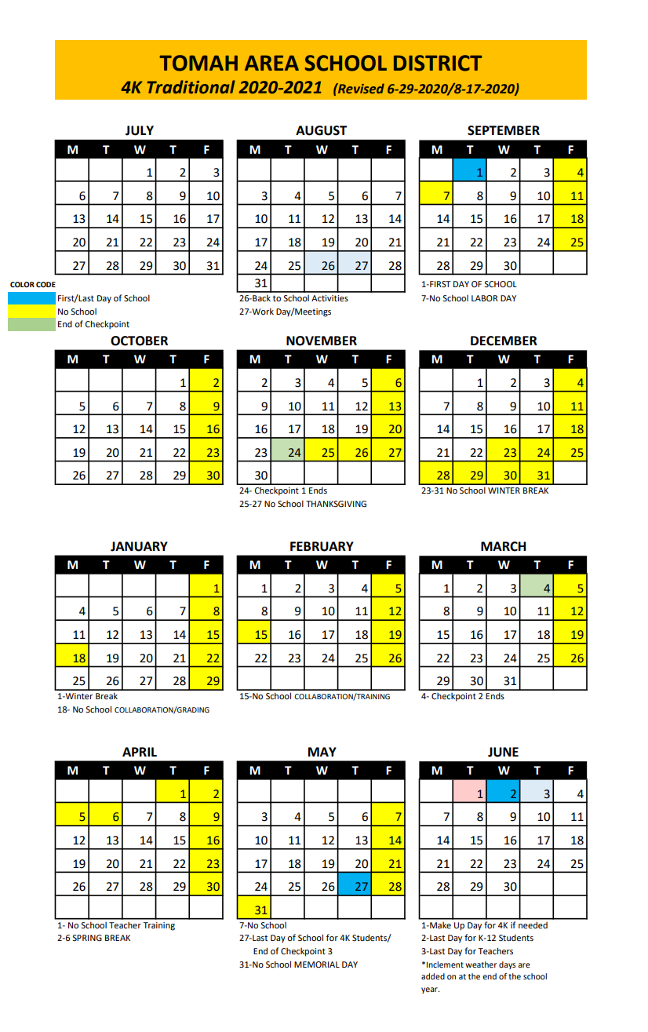
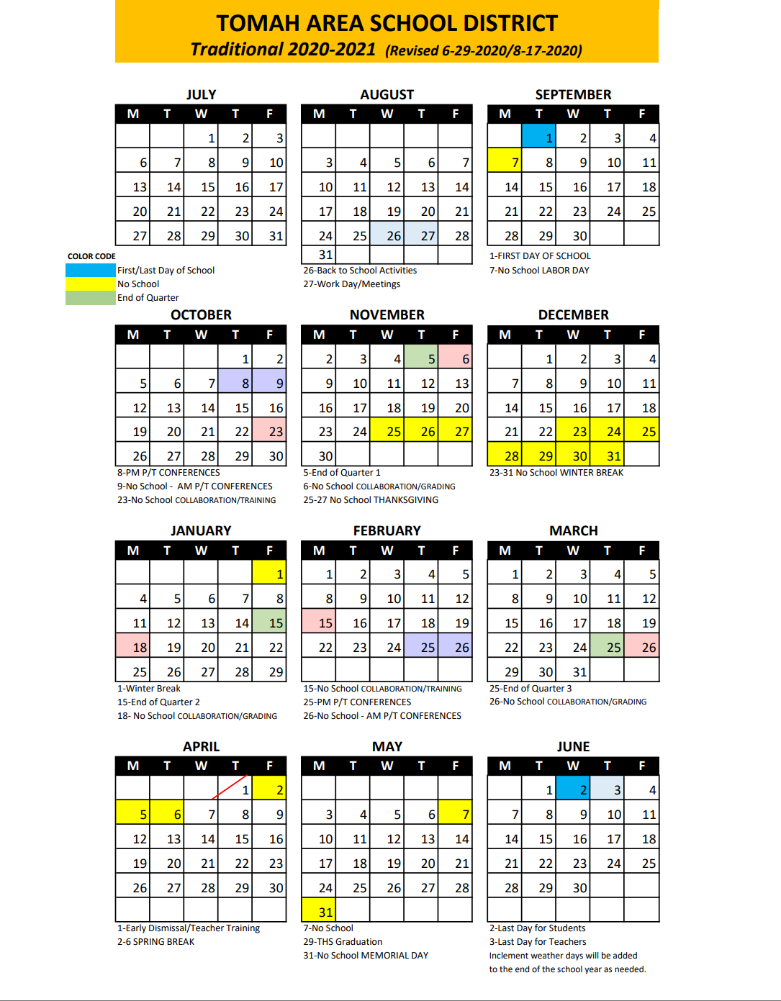

IN THE CLASSROOM
Assessments
Each year the teacher evaluates all children and discusses their progress and plans for entering the next level with the child’s parents. Assessments are given to children for several reasons, primarily to help the teacher work towards the best interests of the child. Assessments will not be used for comparisons of children in individual classes. Our multi-age classrooms and developmentally appropriate activities allow children who are advanced to pursue academic work at their own pace. This is especially beneficial for those who miss the cut-off date for Kindergarten but who are developmentally ready for more challenging work. Students will take state mandated tests.

Virtues
Character is destiny. Virtues are the content of our character. The Virtues Project™ nurtures our children in the skills and qualities they need to be successful in school and in life. Although they are the oldest practices in the world, virtues are essential to the true goal of education – intelligence plus character.
Schools adopt the strategies of The Virtues Project to foster academic excellence and create a culture of caring. The Virtues Project is used by the National Education Association of the U.S. and the Boys & Girls' Clubs of America. Schools across Australia, the Pacific, Africa, India, Europe, and Asia use it as a central tool to enhance social and emotional learning.
Families will receive information specific to The Virtues Project and TAMS.

PARENTS
Communication
Every child is required to have a plastic pocket folder, in which correspondence between parent and teacher is located. It is the duty of both the teacher and parent to check this folder daily for any correspondence from the other party.

We also feel that it is important for parents to communicate any changes in the child’s life that might affect their demeanor at school. Any significant changes should be reported as soon as possible to the child’s teacher. In addition, parents should notify the school of any changes in address, telephone number, change in who is picking up the child, etc. If the change is the birth of a new baby, we would like to share the happiness, but, like all information, it will be kept confidential if the family so chooses. Any legal action affecting the child must be accompanied by a copy of the applicable court decision. Of course, if you have any questions at all, you can always call the school or write a note and send it with your child. Having the request in writing will help us respond more quickly to any of your concerns.

Confidentiality/Privacy
The staff is instructed to never discuss parents or children with other parents or children. Information or opinions concerning parents’ or children’s personality, intellect, behavior, financial background, home, life, etc., is to be kept confidential. Families should respect each other’s rights and privacy. Volunteers are expected to never discuss children with anyone other than the staff member with whom they are volunteering.

Visiting, Tours, Volunteers
Everyone requires some time to adapt to a new environment, especially a child. Starting a new school year is much like starting a new job. The person feels excited and anxious. Our staff is trained to anticipate such feelings and to help the children quickly fit into this new environment comfortably. After a child has attended school for six weeks, observations of the child or visits within the classroom are welcome. We ask parents to wait six weeks so the child has ample time to become familiar with the routine of the classroom. Volunteers/visitors may be allowed in the classroom before the six week time period by invitation of a teacher or approval of the principal. By then children are eager to share their school experiences and expect parents to show an interest in their school activities. The school asks, however, that the parent check with the teacher beforehand if an extended visit to the room is planned. Please use the main entrance and stop in the office for a visitor’s pass upon arrival.

We welcome volunteers during school hours, but unless the parent has made arrangements with the teacher and principal, the volunteer should come ready to focus on helping the classroom without the distraction of personal child care duties. We discourage visits by other children, (relatives, brothers, sisters, and out-of-town guests); exceptions may be made at the discretion of the teacher and approval of the principal. We ask that younger siblings be left with a sitter. To provide an optimum environment, the students need as few distractions as possible during the day.

There are times when the school staff could use and welcome volunteer help. In many cases, special events or programs cannot take place without volunteers. If you are interested in volunteering, please contact the child’s teacher to complete a background check. A background check is required before a person can volunteer.

Visitors from other schools and prospective enrollees are a common sight at our school. We enjoy sharing our environment and philosophy with others and find that discussion is needed to aid visitors in understanding our goals. Administration and PTO members give tours, so our current students are not deprived precious time with their teachers.

Parent Teacher Organization (PTO)
Each family is a vital part of the school organization as a whole. Every family is invited to participate in our PTO. No dues are collected; we simply ask for your participation, interest and support. Meetings are monthly.

Parent Education Meetings
Parent education meetings about child rearing, the Montessori philosophy, our methods of working with children, and other topics of interest may be offered throughout the year.

Volunteer Service
Tomah Area Montessori School is aware of the importance of parent involvement in the overall success of the school. As such, families are encouraged to fulfill at least 15 hours of volunteer service per year for each family enrolled.
Volunteer hours are easy to earn and they help support our school throughout the year. Examples of volunteer hours are as follows: helping with school events, assisting the classroom teacher, being a book parent or room parent, serving on a school committee, assisting during lunchtime, attending a PTO meeting, attending Parent/Teacher Conference, providing snack during your child’s assigned week, completing teacher tasks at home (sewing, cutting materials, etc…), donations of requested school materials ($15=1hour, not to exceed 4 hours of total time), etc... Each family keeps track of the hours they have contributed with a school form kept in a Volunteer Binder in the office.

Parent Concerns
Should the parent have a concern with anything at school, the following steps need to be taken:
- Talk about the concern with your child’s teacher.
- If this does not solve the problem, contact the principal. The teacher may direct you directly to the principal.
- If the problem/concern is still not resolved, the parent may contact the superintendent.
- Finally, if an acceptable resolution has not been reached, the parent may share concerns during the public input of the next Governance Board meeting.

Conferences
Parents at the Children’s House, E1 and E2 level attend conferences with teachers in the fall and spring. Outside of these scheduled conferences, feel free to contact your child’s teacher anytime to check on progress.
Fall Conferences: October 8th and 15th (3:15-5:45 p.m.), October 9th (8:00-11:30 a.m.)
Spring Conferences: Feb 25th and March 4th (3:15-5:45 p.m.), February 26th (8:00-11:30 a.m.)

Student Placement
Student placement is based on individualized assessments and a combination of recommendations from parents, guardians, a school district psychologist and educators.

STUDENTS
Bullying
Tomah Area Montessori School is committed to creating a safe, caring, respectful learning environment for all students through the use of Virtues Project and the Montessori Peace Curriculum.
A complete copy of TASD policy is available at www.tomah.education

Proper Dress
Students are encouraged to dress comfortably. Parents should be aware of their child’s attire and make sure that clothing is appropriate for school and weather conditions. For safety reasons footwear should be appropriate for active play for recess and gym. Children are discouraged from wearing flip flops, shoes with high heels, or shoes that can easily come off while running.

Upon arrival every morning, students will change into a pair of inside shoes (i.e., slippers, Crocs, tennis shoes). Please send an extra set of clothes appropriate for the season. These should be sent in a labeled Ziploc bag. For safety reasons footwear should be appropriate for active play.

Sharing Student Information
The school must have written consent from parent/guardian if you do not want your child to be included in pictures related to school activities.

Student Code of Conduct
The District recognizes and accepts its responsibility to create, foster, and maintain an orderly and safe environment, conducive to teaching and to the learning process. Staff, including administrators, teachers and support staff, must use their training, experience and leadership to create schools and classes where learning is possible. Parents should be aware of their children’s activities, performance and behavior in school, and are asked to cooperate with the school to prevent or address problems. Acceptable forms of conduct will be encouraged in every area of the school environment. Poor conduct may limit privileges. TAMS has a legal duty to ensure the safety of all students, in accordance with TASD District policy.

NUTRITION, HEALTH, and RELATED ISSUES
Food Services
The Tomah Schools Food Service offers breakfast and lunch to Children’s House and Elementary students in the community room. Children are encouraged to participate in the school lunch program. Students may also bring their own lunches from home. We encourage students who bring their lunch to include a variety of nutritious foods and drinks. Candy and soda are strongly discouraged. At the beginning of each month the monthly lunch and breakfast menu will be sent home with your child. If you wish to join your child for lunch, please call the school office by 8:30am.

The breakfast, lunch, and milk program are operated with a computerized account system. A lump sum of money may be deposited in a student’s account on the first day of school. This account will stay with the student through graduation. If a child moves between schools, the account will remain with the child. If a child moves from the district, money deposited may be withdrawn and a check issued upon request. Parents will be notified when their child’s account is nearly depleted. Parents have the ability to view activity on their child’s account via Parental Access. The Tomah Area School District has an online lunch payment system, SchoolPay. SchoolPay is a safe and quick way to deposit money in your student’s lunch account. You can pay with your credit/debit card, however there is a usage fee for this service. Cash and checks are also accepted at your student’s school. You will find a link for the system in the Parent Infinity system. The price of breakfast, lunch, and milk break time, is determined by the School Board annually, and is as follows:

Full Pay Breakfast | $1.75 | Full Pay Lunch | $2.90 | Milk Break | $0.50
Reduced Breakfast | $0.30 | Reduced Lunch | $0.40

During the first week of school, all children will be given an application for free and reduced lunches to take home. We encourage parents to fill these forms out. Please keep in mind we are required to provide every parent with the opportunity to apply. If you qualify for free or reduced lunch, you also qualify for free or reduced breakfast. Milk break, however, needs to be paid by each student, regardless of breakfast/lunch status. Please take advantage of this opportunity from our food service staff to help your child get off on the right foot for an alert and healthy day. Table manners are modeled and expected by all. Inappropriate behavior may result in loss of a privilege.

Healthy Snacks
Your child’s teacher will give you specific details on if or how snack will be offered in the classroom. It is recommended that all food be commercially prepared and packaged if shared with others. All snacks must have nutritional value for their developing body and minds. We highly encourage healthy fruits, vegetables, and proteins for snack time. Teachers will provide an example list of recommended snacks. It is discouraged to have foods that are high in sugar or artificial colors/sweeteners. If unhealthy snacks (i.e. snacks high in sugar/fats/preservatives/artificial ingredients, sodium, etc…) are brought to school, they may be sent back home as this does not follow Montessori philosophy. Students are allowed to have a water bottle to use in the classroom. However, this water bottle should not include juice, water inserts, Gatorade, etc… The classroom water bottle is for water only.

Immunization Records
Please check the chart below for your child’s immunization requirements:
Age/Grade Number of Doses
Pre K (2 years through 4 years) | 4 DTP/D/DTap/DT² |  | 3 Polio | 1 MMR ₅ | 3 Hep B | 1 Var ₆
Grades K through 4 | 4 DTP/DtaP/DT/Td¹ |  | 4 Polio₄ | 2 MMR₅ | 3 Hep B | 2 Var ₆
Grades 5 | 4 DTP/DTap/DT² |  | 4 Polio₄ | 2 MMR₅ | 3 Hep B | 1 Var ₆
Grades 6 through 10 | 4 DTP/DTaP/DT² | 1 Tdap³ | 4 Polio₄ | 2 MMR₅ | 3 Hep B | 1 Var ₆
Eye Examinations
Prior to December 31st of your child’s kindergarten year, a state law recommends that your child undergo an eye exam by an optometrist or and eye evaluation by a physician. Please plan to schedule this component of your child’s pre-kindergarten health testing prior to the start of the year. Free eye exams are available to children whose families meet certain financial criteria and do not have insurance coverage for vision care. You may contact the Wisconsin Optometric Association for more information at (877) 435-2020.

Medications
All medicine will be dispensed only under the following conditions:

NON-PRESCRIPTION MEDICINES:
- Written permission from the parent
- Written instructions from the parent as to the exact dosage/frequency being requested
- All non-prescription medicines must be in their original container

PRESCRIPTION MEDICINES:
- Written instruction from the doctor
- The written instruction must include cautions and possible side effects that need to be noted
- Written instruction must include a statement from the doctor to contact him/her if problems arise with a number where to be reached
- Written permission from the parent
- All prescription medicines must be in their original container with the prescription attached

In all cases, nonprescription medication sent should not exceed two days dosage. Long-term, continuous prescription medication may be one month’s supply. Parents and guardians are encouraged to have their children take medication before or after school whenever possible. Please do not ask our teachers to risk the penalties involved if they do not follow the legal requirements. Forms are available in the school.

SAFETY
Safety and Security
Each year, the Tomah Area School District conducts various drills for the safety of both staff and students. We conduct several fire drills and severe weather drills during the course of the year. We also have, as part of our school crisis plan, several procedures in case of a bomb threat, intruder inside our school and for an intruder outside the school. In addition, we have a plan for the evacuation of our school in case of emergencies such as: toxic chemical spill, loss of heat in winter, gas leak or a power loss, among other unforeseen situations.

TRANSPORTATION
Transportation Department Phone Number: 608-374-7377
The Tomah Area School District has many bus routes and stops throughout the district. TAMS students will be picked up at the closest bus route stop. That bus will transport children to TAMS. 4K students who are released at mid-day will be transported to a residence or day care within the school boundaries of LaGrange, Lemonweir, or Miller Elementary School. Students living outside of these schools’ boundaries will need to be picked up by a parent or assigned parent designee. Parents are welcome to drop students off directly at TAMS.
After school, the students will ride a shuttle bus to the Middle School. The transportation staff has developed an efficient and safe system with the shuttle buses at Tomah Middle School. Students learn the routine and how to transfer buses very quickly. As a safeguard, students wear a tag on their backpack with their name, their teacher’s name and destination. Also, the bus drivers know where students need to go and will assign a buddy if necessary. The teachers from Miller Elementary School are also at the middle school the first few days helping students learn where to go. Parents are welcome to pick students up at TAMS or the Middle School.

TOMAH AREA SCHOOL DISTRICT
Public Notification of Nondiscrimination Policy

It is the policy of the Tomah Area School District that no person may be denied admission to any public school in this district or be denied participation in, be denied the benefits of, or be discriminated against in any curricular, extracurricular, pupil service, recreational, or other program or activity because of the person's race, color, religion, national origin, ancestry, creed, pregnancy, marital status, parental status, sexual orientation, sex (including transgender status, change of sex or gender identity) or physical, mental, emotional, or learning disability (“Protected Classes”) as required by s. 118.13, Wis. Stats. This policy also prohibits discrimination as defined by Title IX of the Education Amendments of 1972 (sex), Title VI of the Civil Rights Act of 1964 (race and national origin), and Section 504 of the Rehabilitation Act of 1973, and the ADA of 1990.

The district encourages informal resolution of complaints under this policy. A formal complaint resolution procedure is available, however, to address allegations of violations of the policy in the Tomah Area School District.

Any questions concerning this policy should be directed to:

Dr. Mike Hanson, District Administrator
Tomah Area School District
129 West Clifton Street
Tomah, WI 54660
(608) 374-7004

Questions concerning s. 118.13, Wis. Stats., or Title IX of the Education Amendments of 1972, which prohibits discrimination on the basis of sex, should be directed to:

Paul Skofronick, Title IX Coordinator
Tomah Area School District
1310 Townline Road
Tomah, WI 54660
(608) 374-7011

Inquiries related to Section 504 of the Rehabilitation Act of 1973 or the ADA of 1990, which prohibits discrimination on the basis of handicap, should be directed to:

Paul Skofronick, Section 504 Coordinator
Tomah Area School District
1310 Townline Road
Tomah, WI 54660
(608) 374-7011
All career and technical education (CTE) courses and programs are offered without discrimination. For a summary of courses and a complete copy of TASD policy, please see www.tomah.education

